Acts 19:1-41
Paul's third journey also originated at Antioch in Syria. How long Paul stayed there after his second journey before setting out a third time is not known. For the most part the third journey covered the same territory as the second one. Since Paul spent three years in Ephesus, the whole trip probably lasted at least four years. When Paul left we do not hear of any travel companions, however, co-workers are present. In chapter 18 Paul traveled from place to place throughout the region of Galatia and Phrygia. Chapter 19 begins with Paul in Ephesus.
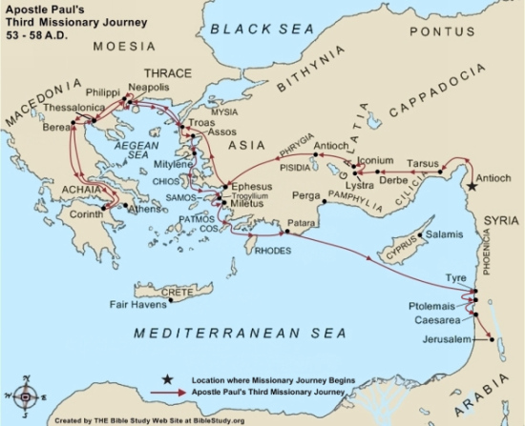

Paul in Ephesus
¹ While Apollos was at Corinth, Paul took the road through the interior and arrived at Ephesus. Why did Paul take the road through the interior? There he found some disciples ² and asked them, “Did you receive the Holy Spirit when you believed?”What question did Paul ask the disciples?
They answered, “No, we have not even heard that there is a Holy Spirit.”
³ So Paul asked, “Then what baptism did you receive?”
“John’s baptism,” they replied.
⁴ Paul said, “John’s baptism was a baptism of repentance. What was John's baptism? He told the people to believe in the one coming after him, that is, in Jesus.” ⁵ On hearing this, they were baptized in the name of the Lord Jesus. What is the baptism of Jesus? ⁶ When Paul placed his hands on them, the Holy Spirit came on them, and they spoke in tongues and prophesied. ⁷ There were about twelve men in all. What happened when they were baptized?
⁸ Paul entered the synagogue and spoke boldly there for three months, arguing persuasively about the kingdom of God. For how long did Paul speak about the kingdom of God? ⁹ But some of them became obstinate; they refused to believe and publicly maligned the Way. What is "the Way"? So Paul left them. He took the disciples with him and had discussions daily in the lecture hall of Tyrannus. Why did Paul leave and go to the lecture hall of Tyrannus? ¹⁰ This went on for two years, so that all the Jews and Greeks who lived in the province of Asia heard the word of the Lord. What was the result of Paul staying for so long?
¹¹ God did extraordinary miracles through Paul, ¹² so that even handkerchiefs and aprons that had touched him were taken to the sick, and their illnesses were cured and the evil spirits left them. How were some people cured?
¹³ Some Jews who went around driving out evil spirits tried to invoke the name of the Lord Jesus over those who were demon-possessed. They would say, “In the name of the Jesus whom Paul preaches, I command you to come out.” Why were some of the Jews invoking the name of Jesus? ¹⁴ Seven sons of Sceva, a Jewish chief priest, were doing this. ¹⁵ One day the evil spirit answered them, “Jesus I know, and Paul I know about, but who are you?” What did the evil spirit know? ¹⁶ Then the man who had the evil spirit jumped on them and overpowered them all. He gave them such a beating that they ran out of the house naked and bleeding. What do we learn about the evil spirit?
¹⁷ When this became known to the Jews and Greeks living in Ephesus, they were all seized with fear, and the name of the Lord Jesus was held in high honor. Whose name became very important? ¹⁸ Many of those who believed now came and openly confessed what they had done. ¹⁹ A number who had practiced sorcery brought their scrolls together and burned them publicly. What had some of the believers still practiced? When they calculated the value of the scrolls, the total came to fifty thousand drachmas. What had some of those who practiced sorcery realized? ²⁰ In this way the word of the Lord spread widely and grew in power. What was the result?
²¹ After all this had happened, Paul decided to go to Jerusalem, passing through Macedonia and Achaia. Where was Paul going to go next? “After I have been there,” he said, “I must visit Rome also.” What were Paul's future travel plans? ²² He sent two of his helpers, Timothy and Erastus, to Macedonia, while he stayed in the province of Asia a little longer. Where were Timothy and Erastus going?

Lecture hall of Tyrannus - Tyrannus was philosopher

A drachma was a silver coin worth about a day’s wages.

The Riot in Ephesus
²³ About that time there arose a great disturbance about the Way. Why do you think there was a disturbance about the Christian teachings? ²⁴ A silversmith named Demetrius, who made silver shrines of Artemis, brought in a lot of business for the craftsmen there. What do you know about Demetrius? ²⁵ He called them together, along with the workers in related trades, and said: “You know, my friends, that we receive a good income from this business. How did these craftsmen earn a living? ²⁶ And you see and hear how this fellow Paul has convinced and led astray large numbers of people here in Ephesus and in practically the whole province of Asia. He says that gods made by human hands are no gods at all. How do you know Paul was successful in his teaching? ²⁷ There is danger not only that our trade will lose its good name, but also that the temple of the great goddess Artemis will be discredited; and the goddess herself, who is worshiped throughout the province of Asia and the world, will be robbed of her divine majesty.”What was Demetrius upset about?
²⁸ When they heard this, they were furious and began shouting: “Great is Artemis of the Ephesians!” ²⁹ Soon the whole city was in an uproar. The people seized Gaius and Aristarchus, Paul’s traveling companions from Macedonia, and all of them rushed into the theater together. What happened to two of Paul's companions? ³⁰ Paul wanted to appear before the crowd, but the disciples would not let him. ³¹ Even some of the officials of the province, friends of Paul, sent him a message begging him not to venture into the theater. What message was being sent to Paul?
³² The assembly was in confusion: Some were shouting one thing, some another. Most of the people did not even know why they were there. Describe the scene. ³³ The Jews in the crowd pushed Alexander to the front, and they shouted instructions to him. He motioned for silence in order to make a defense before the people. What was Alexander trying to accomplish? ³⁴ But when they realized he was a Jew, they all shouted in unison for about two hours: “Great is Artemis of the Ephesians!” What was the crowd's response?
³⁵ The city clerk quieted the crowd and said: “Fellow Ephesians, doesn’t all the world know that the city of Ephesus is the guardian of the temple of the great Artemis and of her image, which fell from heaven? What does the city clerk tell us about the goddess Artemis? ³⁶ Therefore, since these facts are undeniable, you ought to calm down and not do anything rash. ³⁷ You have brought these men here, though they have neither robbed temples nor blasphemed our goddess. How does the clerk describe Paul? ³⁸ If, then, Demetrius and his fellow craftsmen have a grievance against anybody, the courts are open and there are proconsuls. They can press charges. How should the matter be decided? ³⁹ If there is anything further you want to bring up, it must be settled in a legal assembly. What did the city clerk insist must happen? ⁴⁰ As it is, we are in danger of being charged with rioting because of what happened today. What was the clerk afraid would happen? In that case we would not be able to account for this commotion, since there is no reason for it.” ⁴¹ After he had said this, he dismissed the assembly. What happened after the clerk spoke?

Notes:

Artemis - The goddess Artemis was worshiped more widely among the Greeks than any other deity (known as Diana among the Romans). Ephesus was the focal point for countless tourists and pilgrims who visited the magnificent temple each year. The visitors purchased souvenirs manufactured by silversmiths and other craftsmen? There was a spring festival devoted to the worship of Artemis which included athletic, dramatic, and musical contests.

